DYNAMIC ROUTING
Q1. List three differences between static routing and dynamic routing in a table format, using real-world analogies from apps like Google Maps or Swiggy to make each point relatable.
Ans. Differences Between Static Routing and Dynamic Routing
No. | Static Routing | Dynamic Routing | Real-World Example
1 | Manual Configuration: Routes are manually configured by the administrator. | Automatic Configuration: Routes are learned and updated automatically using routing protocols. | Google Maps with a fixed route is like static routing, while automatic route suggestions are like dynamic routing.
2 | No Automatic Changes: Routes do not automatically change when a network path fails. | Automatic Route Changes: Can find alternative paths when network conditions change. | Swiggy delivery partners following a fixed route vs. changing routes when roads are blocked.
3 | Suitable for Small Networks: Easy to manage in small, stable networks. | Suitable for Large Networks: Better for large and changing networks. | A small Swiggy delivery office with fixed connections vs. a large network connecting multiple city branches.

Q2. Open Cisco Packet Tracer and load a pre-configured network file with three routers using RIP. Use the 'show IP route' and 'show IP protocols' commands on each router to observe and write down the RIP-learned routes and their metrics.
Ans.
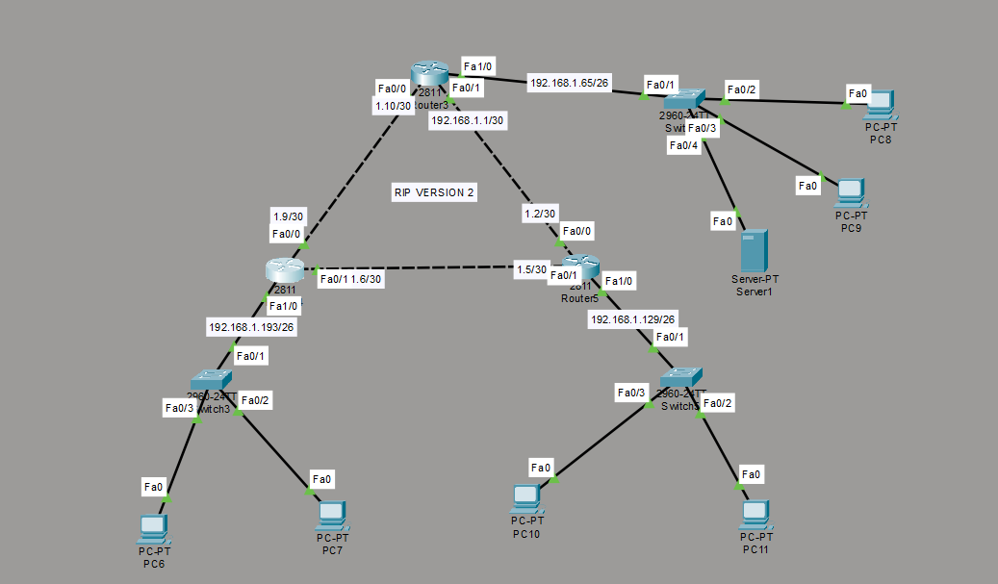
- This is my topology in which I have configure the RIP routing protocol and I have observed that The routing tables show that all three routers are successfully exchanging routing information using RIP Version 2. Each router has learned three remote networks, with a metric of 1 hop and an administrative distance of 120. Some networks have two equal-cost paths, demonstrating that RIP has successfully learned multiple routes between the routers. By using show ip route and show ip protocols command.

Q3. Simulate a network change by shutting down one interface on a router in the RIP-enabled topology. Observe and record how long it takes for the routing tables on the other routers to update and remove the unreachable route. Hint: Use the 'shutdown' command on an interface and monitor with 'show ip route' repeatedly.
Ans. After shutting down FastEthernet1/0 on Router 3, the network 192.168.1.192/26 becomes unreachable. RIP informs the other routers about the network change, and they eventually remove the unreachable route from their routing tables. This demonstrates how RIP automatically updates routing information when network changes occur.
Q4. Explain in 3-4 sentences how dynamic routing in apps like Uber or Zomato delivery tracking is similar to RIP dynamic routing in networks. Focus on how routes or paths are updated automatically in both cases.
Ans. Dynamic routing in apps like Uber or Zomato is similar to RIP routing because both automatically update routes when conditions change. In Uber or Zomato, if a road is blocked or traffic increases, the app suggests an alternative route for delivery. Similarly, RIP automatically updates routing tables when a network path becomes unavailable. Both systems help find an available path without requiring manual changes.

